

!

FIRE SURVEILLANCE, DETECTION AND PREDICTION SYSTEM

SUBMITTED FOR THE COURSE OF: INTERNET OF THINGS

BY

Bindhiya N Koliwad | 16BCB0058
Liza Bini Stephen | 16BCE2251
Sagarika Sardesai | 16BCE2189
D c s Sarath | 16BCI0128
Siddharth Kolagatla | 15BCE0100

SCOPE

INTRODUCTION

A key aspect of fire protection is to identify a developing fire emergency in a timely manner, and to alert the building's occupants and fire emergency organizations. This is the role of fire detection and alarm systems. Depending on the anticipated fire scenario, building and use type, number and type of occupants and criticality of contents and mission, these systems can provide several main functions. First they provide a means to identify a developing fire through either manual or automatic methods and second, they alert building occupants to a fire condition and the need to evacuate. Another common function is the transmission of an alarm notification signal to the fire department or other emergency response organization. They may also shut down electrical, air handling equipment or special process operations, and they may be used to initiate automatic suppression systems. This section will describe the basic aspects of fire detection and alarm systems.

ABSTRACT

Fire alarm (or fire indicator) panel is an early detection and warning system design to communicate warning and evacuation directions to occupants at the detection of a fire. Fire alarm panels are activated in different ways; they may consist of smoke detectors, heat detectors, flame detectors and manual break glass points. Upon the activation of an alarm, the system will activate and tones and sirens will commence, directing the occupants of a building to evacuate. Some fire alarm panels may be connected to a monitoring device which will contact the fire brigade.

There are two different types of fire alarm panels that are used: 1. Conventional 2. Addressable

Conventional

A conventional fire alarm panel organizes it detectors (actuating devices) into zones which are monitored by the fire alarm panel. When a detector registers an alarm, that zone will be considered to be in alarm, giving you an indication of what area of the building the fire is located. These fire alarm panels are advantageous to properties such as small unit blocks, restaurants and properties that require fire alarm detection, however have limited areas as zones.

Addressable

An addressable fire alarm panel is a far more complex system than your traditional conventional fire alarm panel. An addressable system has a LCD display so that emergency services are able to identify the detector in alarm and know its exact location. Each detector or actuating device has its own unique address that is able to state the following:

•Loop

•Detector number •Type of detector •Location of detector

These types of fire alarm panels are invaluable for properties such as schools, hospital, large residential buildings and large commercial buildings.

APPLICATION

- Fire-fighting product identification system

It includes fire-fighting product identification codes, resolution and management. The system is designed to do the following works. They are
1. Fire-fighting product supervision,
2. Management of the products,
3. Improving fire fighting product quality
4. Establishing fire-fighting product market order
5. Preventing production and circulation of fraud imitation firefighting products and so on.
It also includes technical support for maintenance of fire-fighting products, quality tracking, performance evaluation and management of fire-fighting equipment.

- Fire-fighting facility monitoring system

It includes the following division of works. They are
1.Fire-fighting facility state perception,
2. Fire disaster early warning,
3. Household fire alarm,
4. Remote network transmission,
5. Video surveillance access and transmission,
6. Remote monitoring information platform of fire-fighting facilities,
7. Fire-fighting facility availability assessment and diagnostic analysis,
8. Fire fighting facility maintenance and inspection information management,
9. Fire control supervision,
10. Emergency field information services and so on.
The system can ensure the following operations. They are
- The function of fire-fighting facilities,
- Extending fire fighting supervision vision,
- To improve the operation of fire-fighting facilities,
- The timely discover and eliminate fire hazards,
- To strengthen emergency

- Hazard source monitoring and warning system

It includes the following functions. They are
- Hazard source status monitoring,
- Hazard source environmental monitoring,
- Safety hazard inspection and monitoring,
- Hazard source logistics trajectory control,
- Hazard source warning judgment,
- Project construction site hazard source monitoring,
- Hazard source emergency treatment plan,
- Emergency response linkage platform and so on.
The system can predict hazard source potential risks, and can prevent fires, explosions, toxic leaks and other serious accidents caused by hazard source, and providing solid foundation for timely and effective emergency rescue after occurrence of accidents.

IV. Fire-fighting equipment and material monitoring system

It includes intelligent deployment and monitoring of fire fighting equipment, intelligent management of fire fighting equipment emergency repository, fire fighting equipment deployment and monitoring, fire fighting equipment data analysis, national fire-fighting equipment support system and so on. The system can improve information, intelligence and automation level of fire fighting equipment and materials management, and can enhance co-ordination management ability and resource integration sharing of fire-fighting equipment and materials, accelerating fire-fighting equipment management
modernization construction, and further can enhance the core fighting force of public security fire brigade.
V. The emergency field management and control system

It includes on-site monitoring of environmental parameters, fire-fighters personnel positioning and sensing, fire vehicle dynamic monitoring, on-site firefighting equipment and material supervision, on-site fire spread trend forecasting, fire-fighting force situation management, emergency evacuation personnel location perception and so on. The system can improve the emergency field information sharing of fire brigade, disaster judgment, emergency field situation control, police dispatch, command and decision-making as well as other capabilities, and can provide information and technology support for creating modern public security fire fighting strong army.
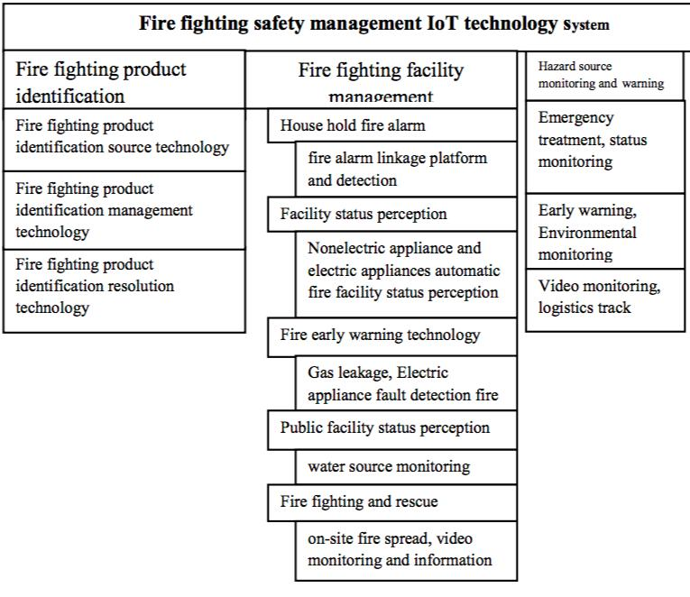

THE WORKING PLAN

Flame Detectors

  - IR detectors: A fire flame emits radiation which is rich in IR and UV energy. In addition, the flicker produced by a flame (1 to 30 Hz) modulates the IR frequencies which can also be detected by suitable photoelectric cells, for example, silicon photocell. The wavelength of operation for the cell is chosen such that the solar radiation does not affect its performance.

  - UV detectors: Since, appreciable amount of optical energy in the UV band is radiated by primarily higher intensity flames, they can be detected from long distances by photoelectric, or photoconductive cells. Majority of UV detectors operate below 2700 A wavelength (solar radiation below 2900 A is absorbed appreciably by air).

Heat Detectors

- Fixed temperature type Smoke Detectors

- Photoelectric type: In this type of smoke detectors, an optical sensor (photo cell, phototransistor, etc.) is always common.

The software constitutes the major part of the system. This is extremely important since ultimate performance of the microcomputer based system depends on the strength of the software. The various features of the software developed for this simulation are discussed briefly.

- Simulation is to be done in Python

- Modularity: The program will be modular so that it is easy to add new modules and
debug the software.
  - Storage and Retrieval The detailed information about type and location of each detector
is stored in the cloud. By doing mathematical manipulations on the received data, the processor determines the channel showing fire and retrieves all previously stored information about it. Automatic maintenance and updating of a log book about the sensors, as and when they are activated will also been provided.

  - Display: Graphical representation has been provided to indicate the location of a place in fire with respect to its surroundings. The display which inform the attending personnel about what is going to happen. Typical graphical display is 'no fire'.

- Alarm: Depending on the type of sensor activation, alarm of a particular frequency is sounded. As and when the sensor gets activated, the clock time freezes. The alarm sound can be stopped only by the operator by acknowledging with the help of one and only one key. After the alarm has been acknowledged, the clock starts again.

The main intention is to hook it up with the automation system so that we would receive alert if it would go off including SMS, push bullet notification to phone, email etc.

The Funky v1 is ideal for the purpose because it is really flat/ tiny and would fit inside the alarm. It will tap into the piezo siren and sleep until the siren is activated. Upon activation, it will make a wireless transmission to my home automation system (Raspberry Pi running Node-Red) for

further processing and alerting on phone.

The piezo siren is activated with a 200ms series of 6.5Khz 50% PWM at 9V so we had to create a small voltage divider + a capacitor to smoothen the signal out and bring it to 3V so the Funky v1 can handle it. A 4.7K:

10K + 1 uF ceramic capacitor works well:

We will then create a miniature PCB using 0603 sized SMD components for the voltage divider

and low pass filter so that all can fit in the fire alarm sensor:

The Funky v1 is | MCP1703 LDO that will supply 3.3V from the
equipped with a | available 9V.

Everything is fit inside the original case.

The Funky will run a Raspberry Pi code; basically it sleeps waiting for a pin-change interrupt from the piezo siren to kick in. It will wake every 30 min to provide heartbeat transmission and let the home automation system know it is alive and well.

HARDWARE COMPONENTS

Purchase a battery operated smoke/fire alarm . It runs on 9V and will make a loud sound if smoke is detected. The main intention was to hook it up with the automation system so that we would receive alert if it would go off including SMS, push bullet notification to phone, email etc.
The Funky v1 is ideal for the purpose because it is really flat/tiny and would fit inside
the alarm. It will tap into the piezo siren and sleep until the siren is activated. Upon
activation, it will make a wireless transmission to my home automation system
(Raspberry Pi running Node-Red ) for further processing and alerting on phone.
The piezo siren is activated with a 200ms series of 6.5Khz 50% PWM at 9V so we
had to create a small voltage divider + a capacitor to smoothen the signal out and
bring it to 3V so the Funky v1 can handle it. A 4.7K:10K + 1 uF ceramic capacitor
works well:

We will then create a miniature PCB using 0603 sized SMD components for the voltage divider and low pass filter so that all can fit in the fire alarm sensor:

The Funky v1 is equipped with a MCP1703 LDO that will supply 3.3V from the available 9V.

Everything is fit inside the original case.

The Funky will run a Raspberry Pi code, basically it sleeps waiting for a pin-change interrupt from the piezo siren to kick in. It will wake every 30 min to provide heartbeat transmission and let the home automation system know it is alive and well.
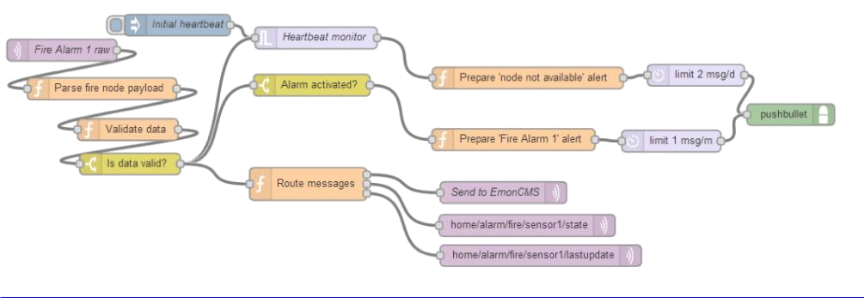

The following consists of the following components

- Parser that analyses the raw payload

- Data validator that makes sure the payload exists and contains the expected range of values

- Heartbeat monitor to make sure we hear from the fire alarm often enough meaning it is up and running

- Alarm activated notification

CIRCUIT
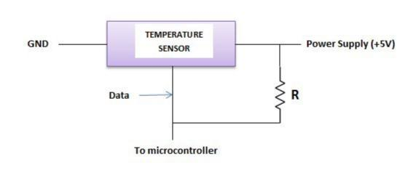

!

DESIGN
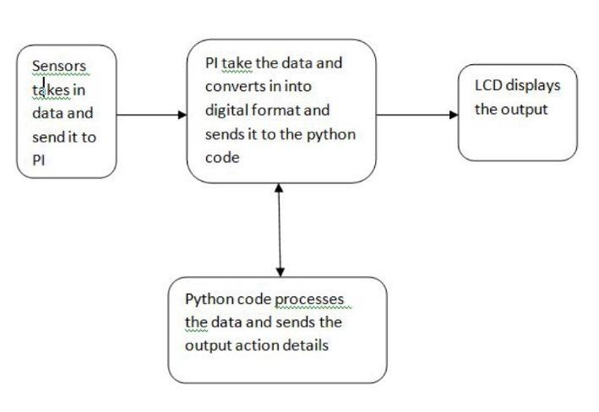

!

Progress

Purchased the required items as listed below:

Raspberry Pi @ Rs 3000

Following @ 320

- Ethernet cable

- Breadboard

- Wires

- Temperature sensor (DS18B20)

- Resistor 4.7 kohms
SIMULATION CODES:-

MAIN.PY:-

import numpy as np

from plot_fire import create_plots
from forest import create_forest
from Tkinter import *

choice = None

def sel():

global choice
choice = var.get()

def get_values():

#print choice
if choice == 1:
direction = "North"
elif choice == 2:

direction = "South"
elif choice == 3:

direction = "East"
elif choice == 4:

direction = "West"
else:

direction = "None"

num = int(blank1.get())
#print num, direction
if direction == "None":
forest_fire = create_forest(num)
else:

forest_fire = create_forest(num, direction)
create_plots(forest_fire)

if (__name__ == "__main__"):

main = Tk()

main.resizable(0, 0)
fnt = (None, 20)

Label(main, text="Wind direction", font=fnt).grid(row=0)
Label(main, text="Size of Forest", font=fnt).grid(row=4)

var = IntVar()
R1 = Radiobutton(main, text="North", variable=var, value=1, font=fnt,\ command=sel)

R2 = Radiobutton(main, text="South", variable=var, value=2, font=fnt,\ command=sel)

R3 = Radiobutton(main, text="East", variable=var, value=3, font=fnt,\ command=sel)

R4 = Radiobutton(main, text="West", variable=var, value=4, font=fnt,\ command=sel)

R5 = Radiobutton(main, text="None", variable=var, value=5, font=fnt,\ command=sel)

blank1 = Entry(main, font=fnt)

blank1.grid(row=4, column=1)
R1.grid(row=1, column=0)
R2.grid(row=1, column=1)
R3.grid(row=2, column=0)
R4.grid(row=2, column=1)
R5.grid(row=3, column=0)

Button(main, text='Quit', bg='red', font=fnt, command=main.destroy).\ grid(row=5, column=0, sticky=W, pady=4)

Button(main, text='Create graph',bg='green', font=fnt, command=get_values).\
grid(row=5, column=1, sticky=W, pady=4)

mainloop()

FOREST.PY:-

from random_direction import generate_random_value

import numpy as np

def create_forest(num, wind = False):
forest = np.zeros((num, num))

- = y = num//2 forest[x, y] = 1 lst = [] #print wind

for i in range(num//2-1):
value = generate_random_value(wind) lst.append(value)

if wind == "East": y += 1

x -= value
elif wind == "West":
y -= 1
x -= value

elif wind == "North":
y -= value
x -= 1

elif wind == "South":
y -= value

x += 1
else:

if value in [1, 2, 3]:
x -= 1

if value == 1:
y -= 1

elif value == 3:
y += 1

elif value in [5, 6, 7]:
x += 1

if value == 5:
y += 1

elif value == 7:
y -= 1

elif value == 4:
y += 1
else:

y -= 1

forest[x, y] = 1
return forest

PLOTFIRE.PY-

import matplotlib.pyplot as plt

import numpy as np

def create_plots(data):
plt.matshow((data+1)%2, fignum=None, cmap=plt.cm.RdYlGn) plt.show()

RANDOM_DIRECTION.PY:-

from random import randint

def generate_random_value(wind = False):
if wind:

return(randint(-1, 1))

return(randint(1, 8))
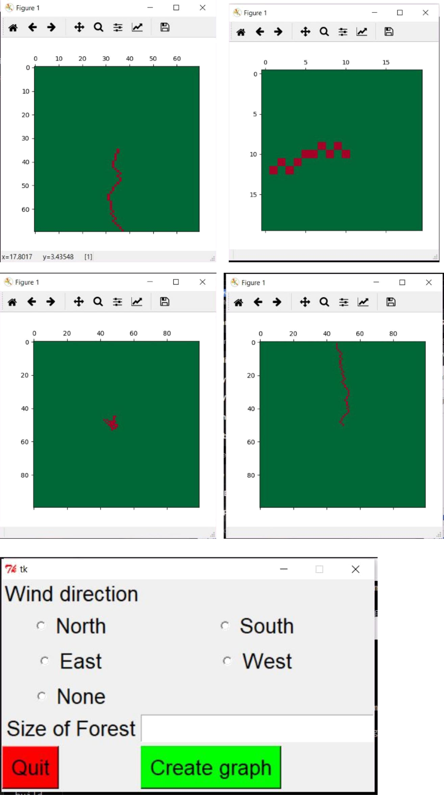
#print generate_random_value(True
CONCLUSION

Firefighting IoT standard system construction can be accelerated, and nationwide IoT platform can be constructed by actively carrying out system integration and information sharing of fire-fighting remote monitoring system. The IoT technology improves the fire-fighting safety management work from traditional fire-fighting to modern fire-fighting. It promote army construction development, full efforts to maintain firefighting safety. It can effectively protect people's lives and property safety. This paper discusses about the design concept and construction of fire fighting IoT model and the steps to be followed to do fire-fighting safety management IoT design. The development of wireless sensors networks with the integration of Internet of Things arise challenges in fire-fighting fields. This new approach gives a reliable solution that can permit to detect fires risks, in order to avoid severe damage of this disaster, when it happens. Application of IoT in fire monitoring is an excellent solution for smart city creation. The system has to be implemented for the success of fire IoT concept. The methods to be followed for fire-fighting IoT, fire monitoring IoT and fire- hazard management IoT are discussed. The layers needed to construct fire IoT are analyzed. Software system for fire monitoring is introduced. This software system is divided into several parts to build set of software system framework. This paper proposes a new fire monitoring system software platform and development proposition. The system is user friendly, precise, stable in operation, multifunctional and concise. Cloud computing and video interface are further modification required in this system

